Contents
Context 3
Report Summary headers 4
Visual Studio solutions 5
HR Reporting environments 6
Live Reports Tracker 7
General Processes 7
Preparing .RDL files in Visual Studio 8
Moving .RDL files in Visual Studio 10
Deploying .RDL files from Visual Studio 11
Using the HR Reporting folder hierarchy 13
Moving .RDL files within the folder hierarchy 13
Creating new report folders 14
Archiving .RDL files 17
Specific Processes 20
New reports 20
DEV Environment 20
QA solution & environment 20
LIVE solution & environment 23
Amended reports 25
QA solution & environment 25
LIVE solution & environment 28
Retired reports 30
Retiring a full suite of reports 30
QA environment 31
LIVE environment 32
Retiring individual report(s) within a suite of reports 32
QA environment 32
LIVE environment 33
Updating the Live Reports Tracker 35
New reports 35
Amended reports 37
Retired reports 38

Additional Guidance
Knowledge Article: not yet written
HOW TO - Manage Reports - Access Permissions within HR Reporting.docx
HOW TO - Manage Reports - Change Processes in OSM.docx
HOW TO - Manage Reports - HR Reporting Environments.docx
HOW TO - Manage Reports - Parameters.docx
HOW TO - Manage Reports - Shared Data Sources.docx
HOW TO - Manage Reports - Shared Datasets.docx
HOW TO - Manage Reports - Troubleshoot Common Errors.docx
HOW TO - Manage Reports - Visual Studio Basics.docx

Context
This document outlines the release and deployment processes for reports in the HR Reporting catalogue. These processes were designed to support robust version control of all the report suites which comprise the HR Reporting catalogue, to ensure that:

- users have access only to the most recent version of any report suite
- there is only a single “active” version of any given report suite at any given time
- previous versions of amended or retired report suites (where applicable) are available in case they need to be viewed or restored to active use

 | NB: The most important aspect of version control for the HR Reporting catalogue is this: versioning is done at the report suite-level, not the .RDL level.

This means that if you update any .RDL files within a report suite, you must update the version number for all the .RDL files within that report suite.

For example, say you are making a change to the report suite PERDEP01 Staff in Post. This report suite consists of 13 separate .RDL files. Even if you are only making a change to one of those 13 .RDLs, you must update the version number on all 13 .RDLs – that is, if you update e.g. the Full Data Set.RDL and promote it from Version 6.0 to Version 7.0, you must also promote the version numbers for the rest of the .RDL files within the report suite to the new version number.

Report suite | .RDL file | Previous version | New version
PERDEP01 Staff in Post | Full Data Set – the one you’re changing | 6.0 | 7.0
 | Full Data Set with Cost Allocation | 6.0 | 7.0
 | Full Data Set with Allowances | 6.0 | 7.0
 | Limited Data Set | 6.0 | 7.0
 | …etc… | … | …

By updating the version numbers for each .RDL within a report suite, you ensure that the entire report suite is promoted from one version to the next. This prevents complications like having Full Data Set (Version 6.0) in the same report as Limited Data Set (Version 2.0).

Version control for HR Reporting is managed in multiple places:
- The “Report Summary” header of the SQL query for each .RDL file
- The Visual Studio HR Reporting_LIVE.sln and HR Reporting_QA.sln
- The HR Reporting LIVE and QA environments
- The Live Reports Tracker document

 | As a rule, the LIVE environment and Visual Studio solution only contain the most recent published version of each .RDL file.  The QA environment and Visual Studio solution will contain both the most recent published version of an .RDL, as well as any previous versions of that .RDL (stored in a separate folder to the current versions).  For more information about different report servers please refer to the HR Reporting environments section.

See below for further information about each of these areas.

Report Summary headers
The SQL query for every .RDL file contains a “Report Summary” header. This header identifies the following attributes of the .RDL file:

Attribute | Meaning
Name | The name of the report suite
Tab name | The name of the individual .RDL file
Version | The major version of the report suite to which this SQL query belongs
Last updated | Month and year of most recent update to report suite
Change ID | OSM Change Request number
NB | Specific notes about the latest version of the report.

A completed example is shown here:

/*************** REPORT SUMMARY *******************
** Name: PERDEP20 Monthly Personnel Changes
** Tab name: Appointment Changes
** Version: 5.0
** Last updated: JULY 2021
** Change ID: 20012493
***************************************************/

Whenever you update the version number of a report suite, you must update the Report Summary header for every .RDL file within that report suite to reflect the new version number, the month & year the report suite was updated, and the OSM Change Request number relating to the update.

 | What if you haven’t actually changed every .RDL file?  Generally speaking, when you update a report suite that contains multiple .RDL files, you will only be changing the SQL code in a few of those .RDLs, not all of them. If you’ve got some .RDL files in your report suite which have not been edited, use this Report Summary Header instead – it’ll make it obvious to anyone who opens the file that the code for this particular .RDL wasn’t updated when the report suite version changed:  /*************** REPORT SUMMARY *******************  ** Name: PERDEP20 Monthly Personnel Changes  ** Tab name: New Starters  ** Version: 5.0  ** Last updated: JULY 2021  ** Change ID: 20012493  ** NB: This code has not been edited; this was a version change only.  ***************************************************/

Providing these details in the Report Summary header enables any user reviewing the SQL query to quickly determine which version of the query they are looking at and when it was last updated. Most importantly, users can also search for the Change ID on OSM and find the full details of and justification for the update – this is a major time-saver when reviewing SQL queries!

Note that for new reports, you will still need to include these details in the Report Summary header. The version will be “1.0” and the change request should detail both the function of the new report and the justification for creating it.

Visual Studio solutions
There are four HR Reporting solutions (.sln files) in Visual Studio: DEV, TEST, QA and LIVE. The DEV solution is used for creating and testing brand-new reports, while the TEST solution is mainly restricted to project testing and testing updated reports against specific data in test environments. Version control in Visual Studio is managed in the HR Reporting_QA.sln and the HR Reporting_LIVE.sln.

Solution | Description | Stores archived copies?
HR Reporting_DEV | This solution is a sandpit for development, and is primarily used as a place to create and unit test new reports. | No – DEV holds no .RDL files for either active or archived report suites.
HR Reporting_TEST | This environment is used to test new and updated versions of reports against a non-production environment where testing is taking place. This would normally happen within the context of a project but may be used to test reports which support new processes being tested in non-production such as those introduced as part of Year End or POG work. It can also be used to regression test the impact of changes to PeopleXD on the existing HR Reporting Catalogue. | No – TEST holds no .RDL files for either active or archived report suites, except for short periods of time when project teams require the reports for testing.
HR Reporting_QA | This solution holds the most recent published versions of all the active reports in the HR Reporting catalogue, as well as back-up copies of the previous versions of each report suite (where previous versions exist) in an archive folder. | Yes – previous versions of the .RDL files for each report suite are held in the Archive folder in the QA solution. The previous versions can be opened in Visual Studio from this Archive folder.
HR Reporting_LIVE | This solution holds the most recent published versions of all the report suites in the HR Reporting catalogue. | No – only the most recent versions of the .RDL files for each report suite are stored in the LIVE solution.

Whether you are creating a new report, amending an existing report, or retiring an existing report, you will need to follow the release and deployment processes for both the HR Reporting_QA and HR Reporting_LIVE solution files at a minimum.

In the QA solution…
- All .RDL files in the new or amended report suite must be saved to the HR Reporting_QA solution with the new version number as a filename suffix on each .RDL, e.g. PERDEP01 Full Data Set_v4 for Version 4.0.
- Optional: It is helpful to periodically move any .RDL files from previous/retired versions of reports from the I:\OUIT\CoreHR Reports\HR Reporting_QA folder to the I:\OUIT\CoreHR Reports\HR Reporting_QA\HR Reporting_QA\Archive subfolder – it keeps the QA solution from getting too cluttered with older versions!

In the LIVE solution…
- Any .RDL files from previous/retired versions of the report suite must be deleted from the LIVE solution.
- All .RDL files in the new or amended report suite must be copied to the LIVE solution from the QA solution.
- The version number suffix on the .RDL filenames (e.g. PERDEP01 Full Data Set_v4) must be removed from the .RDL files in the LIVE solution before the files are deployed to the LIVE report environment.

 | Version numbers are explicitly listed in filenames in the QA solution and environment, so that users can instantly see which version of a report suite they are accessing.  Version numbers are not included in the filenames of the LIVE solution or environment, for two reasons:  - their presence may confuse users, and  - the LIVE solution and environment should only ever hold the most recent version of any report suite, so it is not necessary to state the version numbers in the filenames of the .RDLs.

HR Reporting environments
The HR Reporting environments follow broadly the same format as the Visual Studio solutions detailed above. There are four HR Reporting environments: DEV, TEST, QA and LIVE. The DEV environment is used for creating and testing brand-new reports, while the TEST environment is mainly restricted to project testing. Version control is managed in the HR Reporting QA environment and the HR Reporting LIVE environment.

 | As with the Visual Studio solutions, only the HR Reporting QA environment stores archived copies of report suites.

Whether you are creating a new report, amending an existing report, or retiring an existing report, you will need to follow the release and deployment processes for both the HR Reporting_QA and HR Reporting_LIVE environments.

In the QA environment…
- All .RDL files in the new or amended report suite must be deployed to the QA environment and filed in the appropriate report folder on the server.
- The version number of the new/amended report suite should be recorded or updated in the report folder’s Description field.
- Any previous/retired versions of the .RDL file(s) must be removed from their current report folder and filed in the _Back-Up Versions folder.

In the LIVE environment…
- Any previous/retired versions of the .RDL file(s) must be deleted from the LIVE environment.
- All .RDL files in the new/amended report suite must be deployed to the LIVE environment and filed in the appropriate report folder on the server.

Live Reports Tracker
The Live Reports Tracker is a spreadsheet which contains details of all active reports in the HR Reporting catalogue, including each report’s name, where it is filed in the HR Reporting folder hierarchy, and which AD groups it is shared with.

Version control is not managed as such in the Live Reports Tracker, however this document must be updated whenever you create a new report, retire an existing report, or amend any of the following aspects of an existing report:

- The report’s prefix (e.g. PERDEP01)
- The report’s name (e.g. Staff in Post)
- The report’s location within the HR Reporting folder hierarchy (e.g. Home > Personnel > Current Reports)
- The AD groups which have permission to view the report in the HR Reporting_LIVE environment (e.g. HRIS-RR-PERDREP – Personnel).

Refer to the process below for further information on when and how to update the Live Reports Tracker.

General Processes
It’s important to note that the fundamental steps for releasing and deploying new/amended reports are nearly identical, so they have been included at the top of the Processes section for easy reference. These steps are:

- Preparing the .RDL files in Visual Studio
- Moving the prepared .RDLs into the appropriate Visual Studio solutions
- Deploying the .RDLs to the appropriate HR Reporting environments.
- Using the HR Reporting folder hierarchy

Retired reports are managed differently, so if you are retiring a report, you may wish to skip to that section.

STOP: All changes to the HR Reporting catalogue (new reports, amended reports, retired reports) must be recorded in detail in OSM via a formal change request. Each of the steps listed in the guidance below should have a corresponding task on an OSM change.

Do not proceed until you have raised a change request in OSM and assigned yourself the relevant tasks!

See: HOW TO - Manage Reports - Change Processes in OSM.docx

Preparing .RDL files in Visual Studio
Before you can release and deploy a new or amended report, you will need to have the necessary .RDL files in place in Visual Studio. Both new and amended reports are created by copying existing .RDL files and editing them as required, depending on what you are trying to achieve.

 | Never, ever make changes to an existing .RDL file. Always make a copy and edit that instead.

To copy an .RDL file, go into the Visual Studio solution which contains the .RDL. Expand the Reports list within the Solution Explorer to view all the .RDL files available within your current solution.

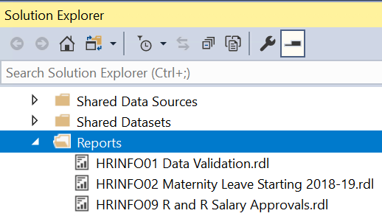

Select the .RDL file you wish to copy.

- If you are amending a report, the file you need to copy is the current version of the .RDL you want to modify.
  - Example: if you are creating version 2.0 (_v2) of RECSUP01 Applicant Detail Per Vacancy, you should copy the .RDL file RECSUP01 Applicant Detail Per Vacancy_v1.

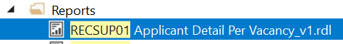
- If you are creating a new report, the .RDL file you need to copy is the MASTER Report Template.rdl in the HR Reporting_DEV solution. This template .RDL file contains all of the necessary formatting in the report Tablix, so that you don’t have to add it in when you render your new report:

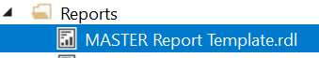

Once you’ve selected the .RDL you wish to copy, enter CTRL+C to copy the file, then enter CTRL+V to paste the copied file into the Reports list. The copied file will appear at the bottom of the Reports list, with the prefix “Copy of…”:

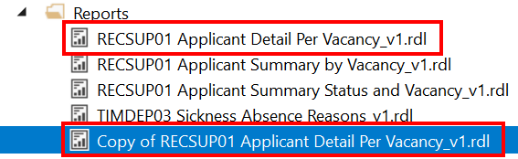

Right-click your “Copy of…” .RDL file and select “Rename”:

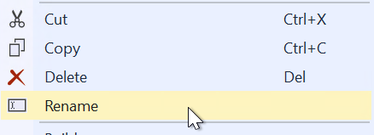

Amend the name of the .RDL file as necessary, being sure to add the new version number to the end of the filename. Hit ENTER to save your changes.

 | What about new reports?  If you are creating a brand-new report, you should rename the .RDL file with the prefix of your new report suite and the name you have chosen for the .RDL file. Remember that the version number for new reports is always _v1:  - Example: TIMDEP40 Sickness Absences over Time_v1.RDL  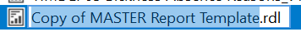

Once you have created a copy of the .RDL file you wish to modify, you can make your changes to the copy. See the guide for rendering reports in Visual Studio if you need help.

Save your changes when you are finished. Your new .RDL file is now ready for the release and deployment process.

 | Remember: versioning is done at the report suite-level, not the .RDL level. If you are amending a report suite that contains multiple .RDLs, you will need to create new copies of every .RDL file in the report suite, make the necessary amendments, and save your changes before you can begin the release and deployment process for your amended report.

Moving .RDL files in Visual Studio
A key aspect of the release and deployment process is moving .RDL files from one HR Reporting solution to another in Visual Studio.

- When you develop a new report, you will need to move the new report’s .RDL file(s) across three solutions:
  - HR Reporting_DEV HR Reporting_QA HR Reporting_LIVE
- When you amend an existing report, you will need to move the amended report’s .RDL file(s) across two solutions:
  - HR Reporting_QA HR Reporting_LIVE¹

To move an .RDL file from one solution to another, open the solution you want to add the .RDL to – for example if you are moving an .RDL from HR Reporting_DEV to HR Reporting_QA, you should open the QA solution.

Go to the Solution Explorer, then select the Reports folder and right-click it to open the sub-menu. Select Add > Existing Item… (or type Shift + Alt + A):

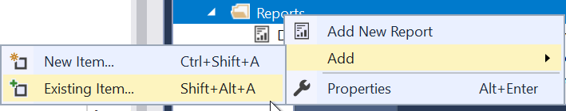

The solution folder on I:\OUIT\CoreHR Reports\ will open. This folder contains all the files which belong to your current HR Reporting solution:

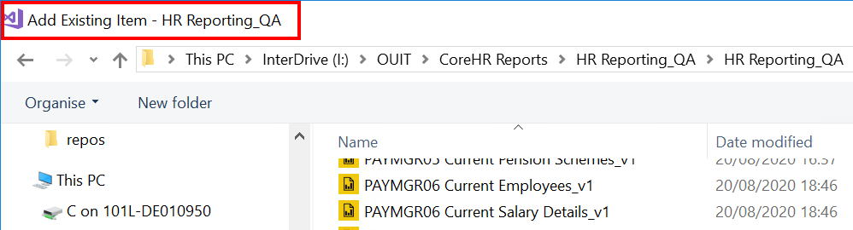

If you want to add an .RDL file from a different solution, navigate back to the main I:\OUIT\CoreHR Reports folder and select the solution folder you want to open.

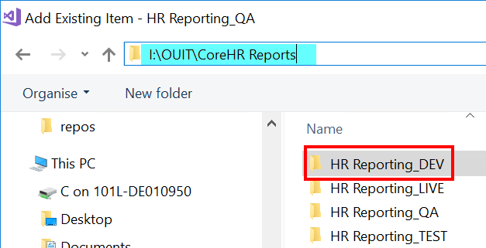

In this example, you can see from the title bar and the file path that you are selecting files from the DEV solution to add them to the QA solution:

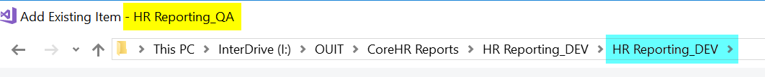

Scroll through the solution folder until you find the file you want to add to your current solution, then select it and click Add:

The file you have added will now appear at the bottom of the Reports list within the Solution Explorer of your current solution:

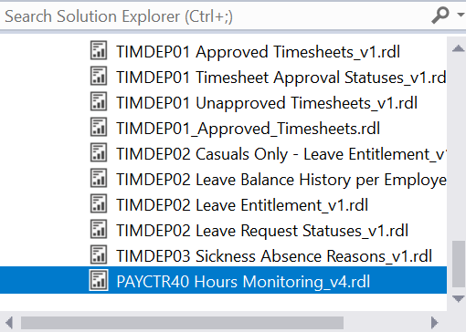

You can move multiple .RDL files to your current solution simultaneously – simply select all the files you wish to move before you click Add. All files you have added will appear at the bottom of the Reports list within the Solution Explorer of your current solution.

Deploying .RDL files from Visual Studio
Once you have prepared your new/amended .RDL files and ensured that they are present in the appropriate Visual Studio solution, you are ready to deploy the .RDLs to the HR Reporting environments.

 | The .RDL files should only ever be deployed in the following order:  - (Optional) Deploy into the DEV or TEST environments. This is only required if you are testing a newly-developed report or if you need to test a report against a specific non-production Reporting environment (TEST can be configured to “point at” UOXZ, UOXC and UOXU, as required).  - Deploy into HR Reporting QA environment. This is where end-users can perform UAT and confirm if they are happy for your new/amended report suite to be published.  - Deploy into HR Reporting LIVE environment. Only do this after receiving formal change approval in OSM.

The deployment process is the same across all HR Reporting solutions and environments, and the steps are outlined below.

To deploy an .RDL file, select it in the Solution Explorer pane and right-click. Select “Deploy” from the right-click menu:

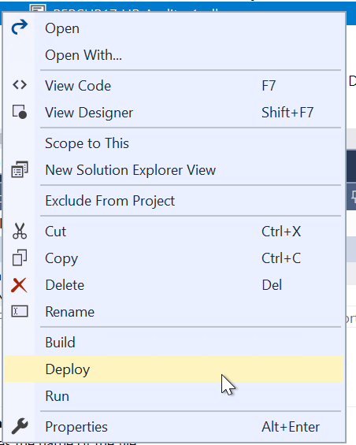

The progress of the deployment will display in the Output pane at the bottom of your screen. Look at the final message to see whether your deployment has succeeded or failed:

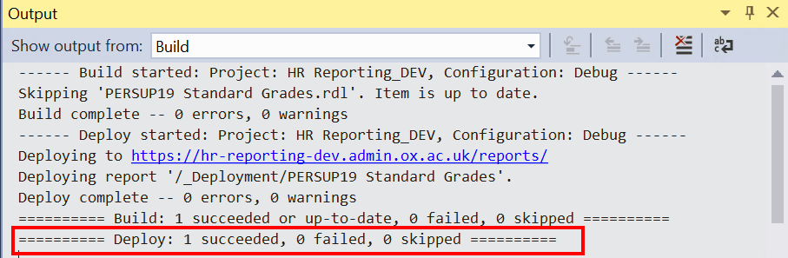

You can deploy multiple .RDL files simultaneously – simply select all the files you wish to deploy before you select “Deploy” from the right-click menu. Each file will be deployed individually by Visual Studio, and the results of your deployment will be displayed in the Output pane at the bottom of your screen:

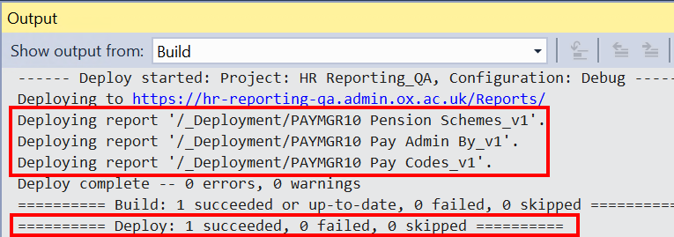

If your deployment has succeeded, the file will be available in the HR Reporting environment’s Home _Deployment folder.

 | What if your deployment fails?  Sometimes, Visual Studio will be unable to deploy your .RDL file. This can be because…  - There is something wrong with the format of the .RDL file itself.  - The .RDL file refers to a shared dataset which doesn’t exist in the HR Reporting environment you’re deploying to.  - The HR Reporting environment is temporarily unavailable, so Visual Studio can’t contact it.  If your deployment has failed, you will see an Error List pane with a description of the reason for the failure; for example:  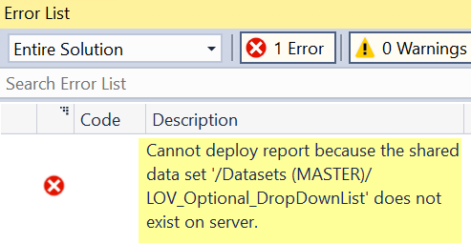  Refer to the guidance for troubleshooting common errors to resolve the problem, and click “Deploy” when you are ready to retry deployment.

Using the HR Reporting folder hierarchy
Once you have successfully deployed the .RDL file(s) for your new/amended report suite, you must move the file(s) to the appropriate location within the HR Reporting folder hierarchy.

 | NB: Review the HOW TO - Manage Reports - Access Permissions within HR Reporting.docx for further information on what the reporting folder hierarchy is and how it is used.

If you’ve created a new report, you’ll have to set up a new folder within the folder hierarchy before you can move your .RDL files. If you’ve amended an existing report, you’ll need to archive the previous version of the report suite before you can move your .RDL files.

Moving .RDL files within the folder hierarchy
To move .RDL files from one folder to another within an HR Reporting environment, go to the folder in which the .RDL files are currently located and click the tick-box next to each .RDL you wish to move:

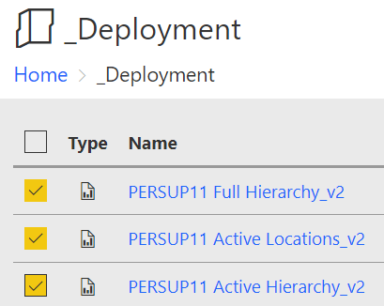

At the top of the screen, click “Move”:

The Select folder window will open. From here, you can navigate to the appropriate navigation folder subfolder report folder where your .RDL file(s) should be sent.

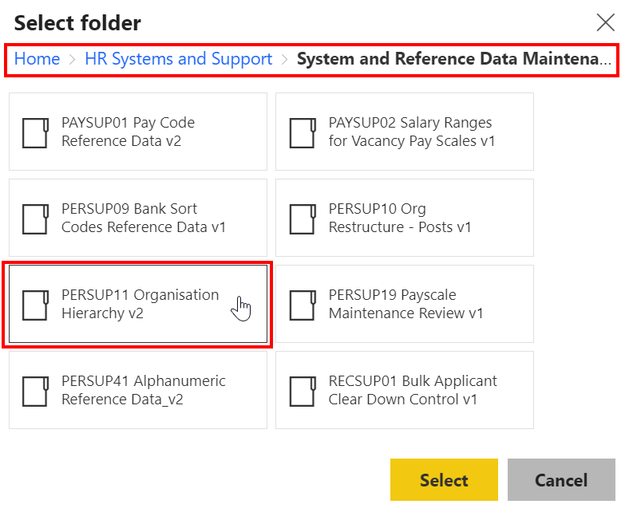
Click the appropriate report folder, then click “Select”. The screen will refresh and the Select folder window will close. The .RDL files you’ve moved will disappear from your current folder, so you should navigate to the folder you just selected to check that the .RDLs you’ve moved are appearing correctly there:

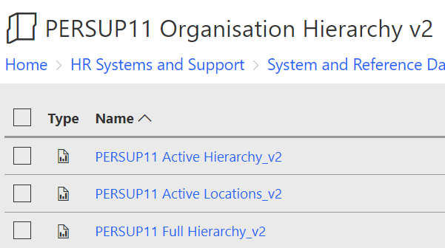

Creating new report folders
Before you can file the .RDLs for your new report, you’ll need to ensure you’ve actually got a report folder in place for them. Follow this process to create a new report folder in any HR Reporting environment.

 | Please ensure that you are fully familiar with the use of folder access permissions within HR Reporting before you create a new folder. This is essential in order to avoid data breaches.

 | Where should your new report folder go?  Some aspects of creating a new report folder are common sense – payroll reports will go in the Payroll folder, personnel reports will go in the Personnel folder, etc. But if your navigation folder contains subfolders, which subfolder should you choose?  Subfolders often have names that are meaningful to the main users of the reports located within them, e.g. “Relocation” within the Payroll folder, or “Athena SWAN Reports” within the HR Analytics folder. If you are unsure of where to file your new report, speak to the end-user who requested it – they may be able to suggest a logical subfolder.  If the end-user can’t advise you, or you are still unsure, speak to the HR Functional Analysis team for guidance.

Navigate to the appropriate navigation folder or subfolder to which your new report belongs. At the top of the screen, click “New” and select “Folder” from the drop-down menu:

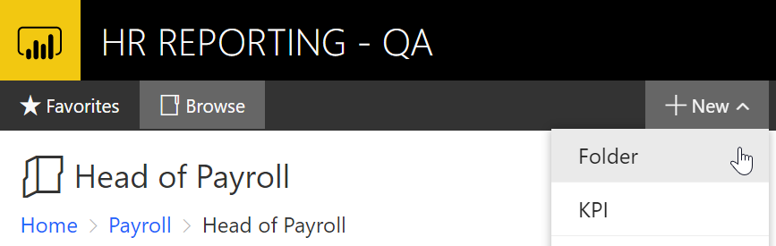

A pop-up will open, prompting you for the folder name. Enter the prefix and name of your new report suite:

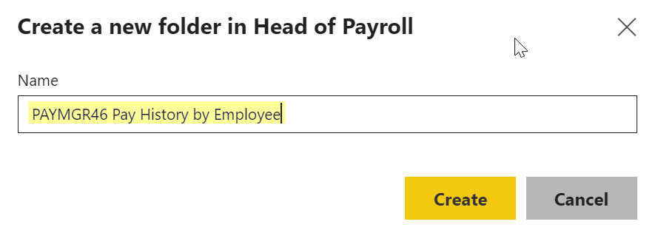

Click “Create” to create the report folder. It will appear in the folder list:

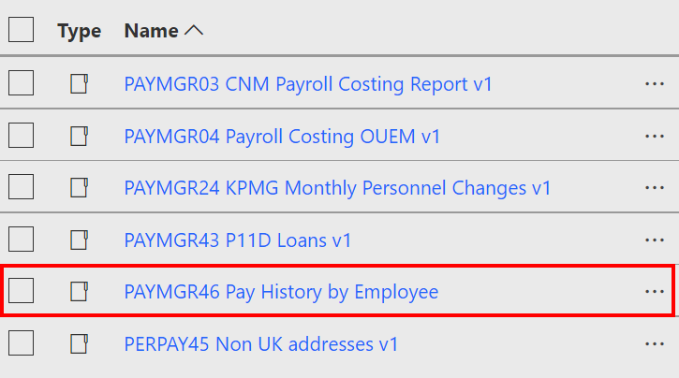

Now that your folder exists, you need to apply the appropriate user access permissions. Click the ellipsis (…) symbol next to the report folder’s name and select “Manage”:

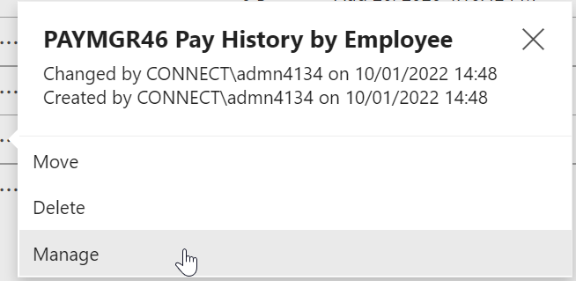

Select the Security tab from the left-hand side of the screen:

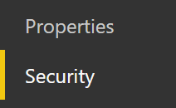

A list of all the users and AD groups which have access to your new report folder will be displayed. This list is inherited from the navigation folder or subfolder in which your new report folder sits, so the first thing you need to do is to customise your report folder’s security.

 | Note: Customising your report folder’s security breaks the link between the report folder and its navigation folder/subfolder. This means that you can make changes to the access permissions of the navigation folder/subfolder and those changes will not automatically be reproduced for your report folder. This is very important – it means security can be individualised for every report so that only the right people have access to the right reports.

Click “Customize security”:

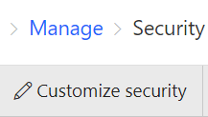

A warning message will appear; click “OK” to dismiss it.

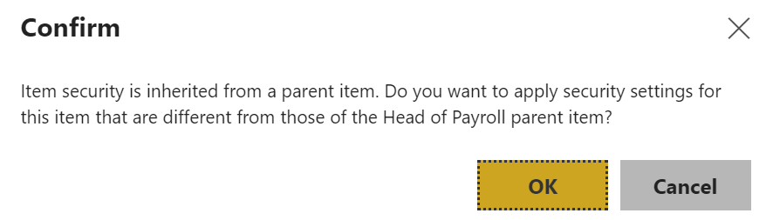

The screen will refresh and you will now have the option to add AD groups to or remove them from your report folder’s security profile:

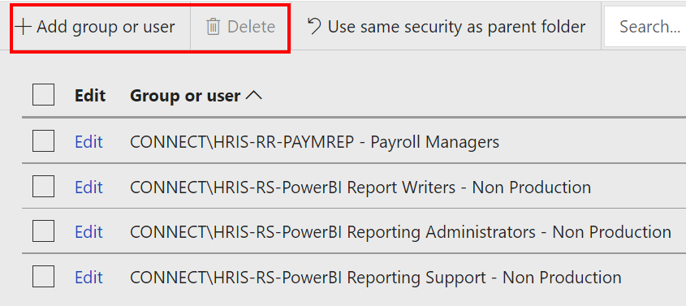

Archiving .RDL files
Whenever you amend a report, you will need to archive the previous version of the report suite in the _Back-Up Versions folder in the HR Reporting QA environment. This is to ensure that older versions of reports can be restored to use, if required.

 | All back-up copies of report suites are held in the HR Reporting QA environment, so there is no need to retain previous versions in the LIVE environment.

Before you can archive a report, you must first check whether a report folder exists for your report within the _Back-Up Versions folder.
Navigate to the _Back-Up Versions folder and scroll down the list of reports to see if a report folder for your amended report suite already exists:

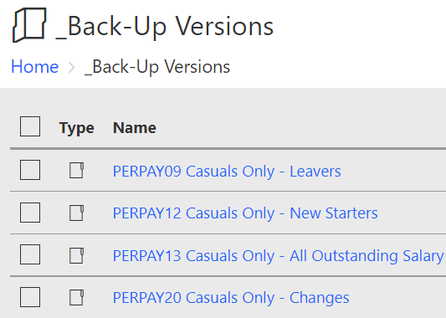

If there is no report folder for your report suite within the _Back-Up Versions folder, you will need to create one. At the top of the screen, click “New” and select “Folder” from the drop-down menu:

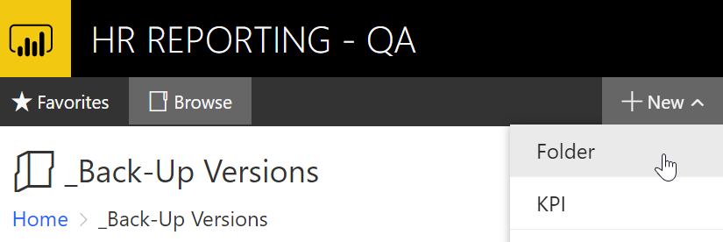

A pop-up will open, prompting you for the folder name. Enter the prefix and name of your report suite:

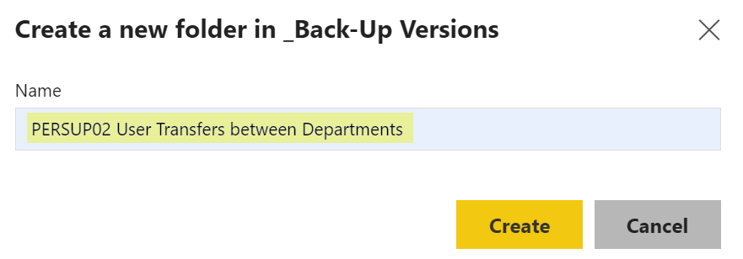

Click “Create” to create the report folder. It will appear in the folder list:

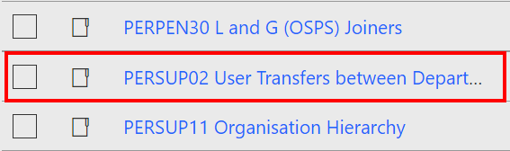

Now you are ready to archive the .RDLs from the previous version of your amended report suite. Exit the _Back-Up Versions folder and navigate back to the active report folder, selecting all .RDLs which belong to the previous version of the report suite:

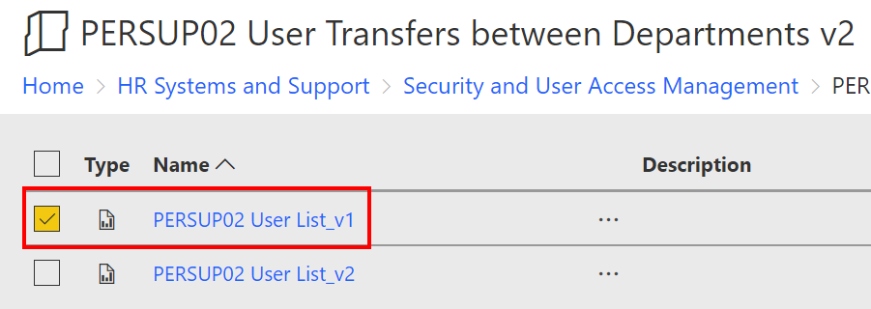

At the top of the screen, click “Move”:

The Select folder window will open. From here, you can navigate to the _Back-Up Versions folder and from there to your report suite’s archive folder:

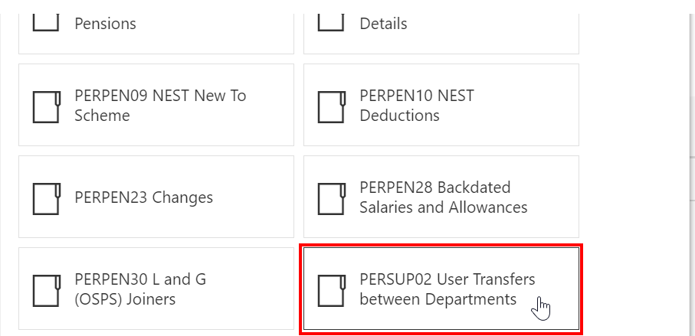

Click your report’s archive folder to enter it, then click “Select”.

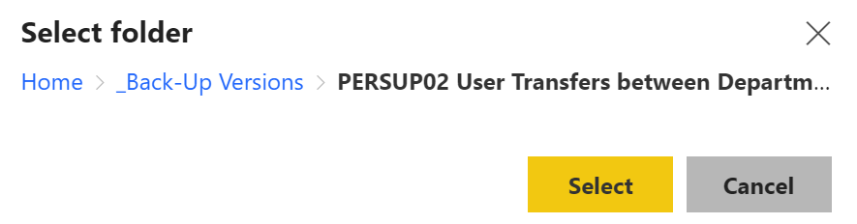

The screen will refresh and the Select folder window will close. The .RDL file(s) you’ve moved will no longer appear in the active report folder. Navigate to your report’s archive folder in _Back-Up Versions to check that the archived .RDLs are appearing there:

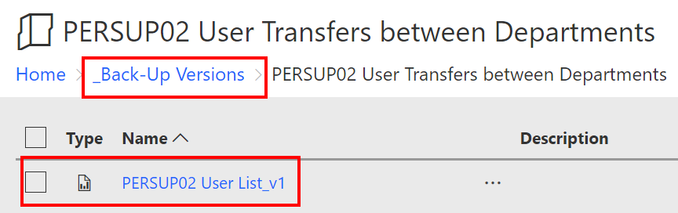

Specific Processes
The basic processes outlined above apply equally to new and amended reports, however there are some specific steps for new reports vs amended reports which are covered in more detail here.

New reports
If you are adding a new report to the HR Reporting catalogue, follow the steps below.

DEV solution & Environment

Develop the new report
Use the Preparing .RDL files in Visual Studio process to create a new report within the DEV solution.

Complete unit testing
Check that the new code you have written runs successfully in the DEV server, that the parameters and conditions apply work as expected, that you get no error messages when deploying the DEV server and that the formatting is correct on the output of the file. You may optionally choose to carry out further testing within the TEST environment before progressing the report into the version-controlled QA environment.

QA solution & environment

Move the .RDL files.
Begin by moving the .RDL files for your new report from the HR Reporting_DEV solution into the HR Reporting_QA solution.

Add version numbers to .RDL filenames
Once you’ve moved your new .RDL files into the HR Reporting_QA solution, you will need to add the version number to each filename. For new reports, the version number is always _v1.

Right-click your .RDL file in the Reports list within the Solution Explorer. The right-click menu will open. Select “Rename”:



Add the version number to the end of the filename and hit Enter to save your changes.

Deploy .RDLs to HR Reporting QA environment
Now that you’ve added the version numbers to the .RDLs of your new report, you can deploy the files to the HR Reporting QA environment. The .RDL file(s) you have just deployed will be located in the QA environment’s _Deployment folder.

Set up a new report folder
You now need to create a new report folder within the QA environment’s folder hierarchy so that you can move your .RDL files out of the _Deployment folder.

Once you’ve created the new report folder, click the ellipsis (…) symbol next to the report folder’s name and select “Manage”:



You will be taken to the report folder’s Properties tab. Add the version number to the “Name” and “Description” fields, as shown below:

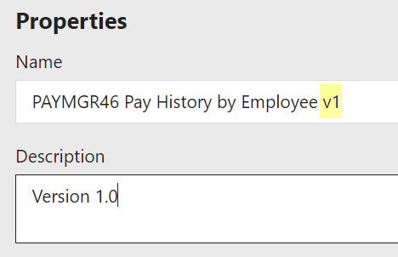

This enables anyone entering the navigation folder/subfolder to see which version of a report suite is available there. Click “Apply” to save your changes.

Move .RDL files into the new folder
Once you’ve set up the folder for your new report, you can move your .RDL file(s) into it. Navigate to Home _Deployment to select your .RDL files and then follow the linked process to move the .RDLs into your new report folder.

Check that your files are appearing correctly in the new report folder, then share a link to the report folder with the end-user who requested the creation of the new report, and ask them to perform UAT.

Once the end-user has confirmed that the report has passed UAT, you can submit your OSM Change Request for approval. Refer to the HOW TO - Manage Reports - Change Processes in OSM.docx for more information.

When you are happy that your new report has passed UAT in the HR Reporting QA environment, you must remove the originally developed report from the HR Reporting DEV environment, as reports are not kept on this server permanently and we need to keep the server tidy. All final copies of newly-developed reports should be stored in the QA (and eventually LIVE) environments – they only reside exist in DEV for as long as it takes to develop them.

LIVE solution & environment

STOP: All newly-developed .RDL files must be tested and approved by either the end-user who requested the new report, a project testing team or the HR Functional Analysis team. You must record the result of the User Acceptance Testing (UAT) on your OSM change request. Note that if the end-user has emailed you directly (rather than via the linked OSM incident), you must attach the email to the change request for future reference.

Your OSM change request must also have formal approval before you can add the .RDL files for your new report to the HR Reporting LIVE solution in Visual Studio, or deploy them to the HR Reporting LIVE environment.

Do not proceed until you have explicit confirmation from either the end-user or the HR Functional Analysis team that the newly-developed .RDL files have passed UAT and your OSM change request has been approved and scheduled for implementation. You may wish to refer to the “HOW TO - Manage Reports - Change Processes in OSM” document.

Move the .RDL files
Once your OSM change request has been scheduled for implementation, you are ready to make your new report available for users on the HR Reporting LIVE server.

Begin by moving your .RDL files from the HR Reporting_QA solution into the HR Reporting_LIVE solution.

Remove version numbers from .RDL filenames
It is not necessary to include version numbers in the filenames of .RDLs in the HR Reporting_LIVE solution, because the LIVE solution should only ever hold the most recent version of any report suite.

To remove the version number from a filename, right-click your .RDL file in the Reports list within the Solution Explorer. The right-click menu will open. Select “Rename”:



Remove the version number (e.g. “_v1”) from the end of the filename and hit Enter to save your changes. You will need to repeat this step for all the .RDL files in your new report suite.

When you are done editing your .RDL filenames, enter Ctrl + Shift + S or click the “Save All” icon to save your changes to the .RDL files:

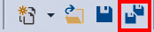

Deploy .RDLs to HR Reporting LIVE environment
You are now ready to deploy the .RDL files to the HR Reporting LIVE environment. The .RDL file(s) you have just deployed will be located in the _Deployment folder.

Set up a new report folder
You now need to create a new report folder within the LIVE folder hierarchy before you can move your .RDL files out of the _Deployment folder.

Once you’ve created the new report folder, click the ellipsis (…) symbol next to the report folder’s name and select “Manage”:



You will be taken to the report folder’s Properties tab. Add the version number to the “Name” and “Description” fields, as shown below:



This enables anyone entering the navigation folder/subfolder to see which version of a report suite is available there. Click “Apply” to save your changes.

Move .RDL files into the new folder
Once you’ve set up the folder for your new report, you can move your .RDL file(s) into it. Navigate to Home _Deployment to select your .RDL files and then follow the linked process to move the .RDLs into your new report folder.

Check that your files are appearing correctly in the new report folder before marking your OSM change request as “Implemented”.

Update the Live Reports Tracker
Follow the process below to add your new report’s details to the Live Reports Tracker.

Amended reports
If you are updating an existing report in the HR Reporting catalogue, follow the steps below.

QA solution & environment

 | New versions of existing reports are usually developed within the HR Reporting_QA solution in Visual Studio. For this reason, there is no step to “Move the .RDL files” for the amended reports process.

Add version numbers to .RDL filenames
Follow the Preparing .RDL files in Visual Studio process to create a copy of each of the .RDLs within the report suite you are amending. Via this process, you will update the version numbers of the .RDLs you are amending directly; however, before you can release and deploy the amended report suite, you will need to add the new version number to any other .RDLs within the report suite. This is to ensure that all the .RDLs in the report suite have the same version number.

For amended reports, the version number will always be _v(X + 1), where “X” is the previous version.

- Example: If the previous version was _v8, the amended version is _v(8+1) = _v9.

Right-click your .RDL files in the Reports list within the Solution Explorer. The right-click menu will open. Select “Rename”:



Add the new version number to the end of the filename and hit Enter to save your changes.

Update the Report Summary headers
Now you need to ensure that the Report Summary header in the SQL query for each amended .RDL file contains all the relevant details.

To open an .RDL, select it from the Reports list and double-click it. Once the file has opened, go to the Report Data pane on the left side of the screen and select DataSet1 from the “Datasets” folder (the SQL query for any .RDL file is always contained within DataSet1):

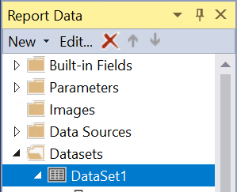

Double-click to open DataSet1 in the Dataset Properties window. The SQL code for the query will be visible in the Query pane:

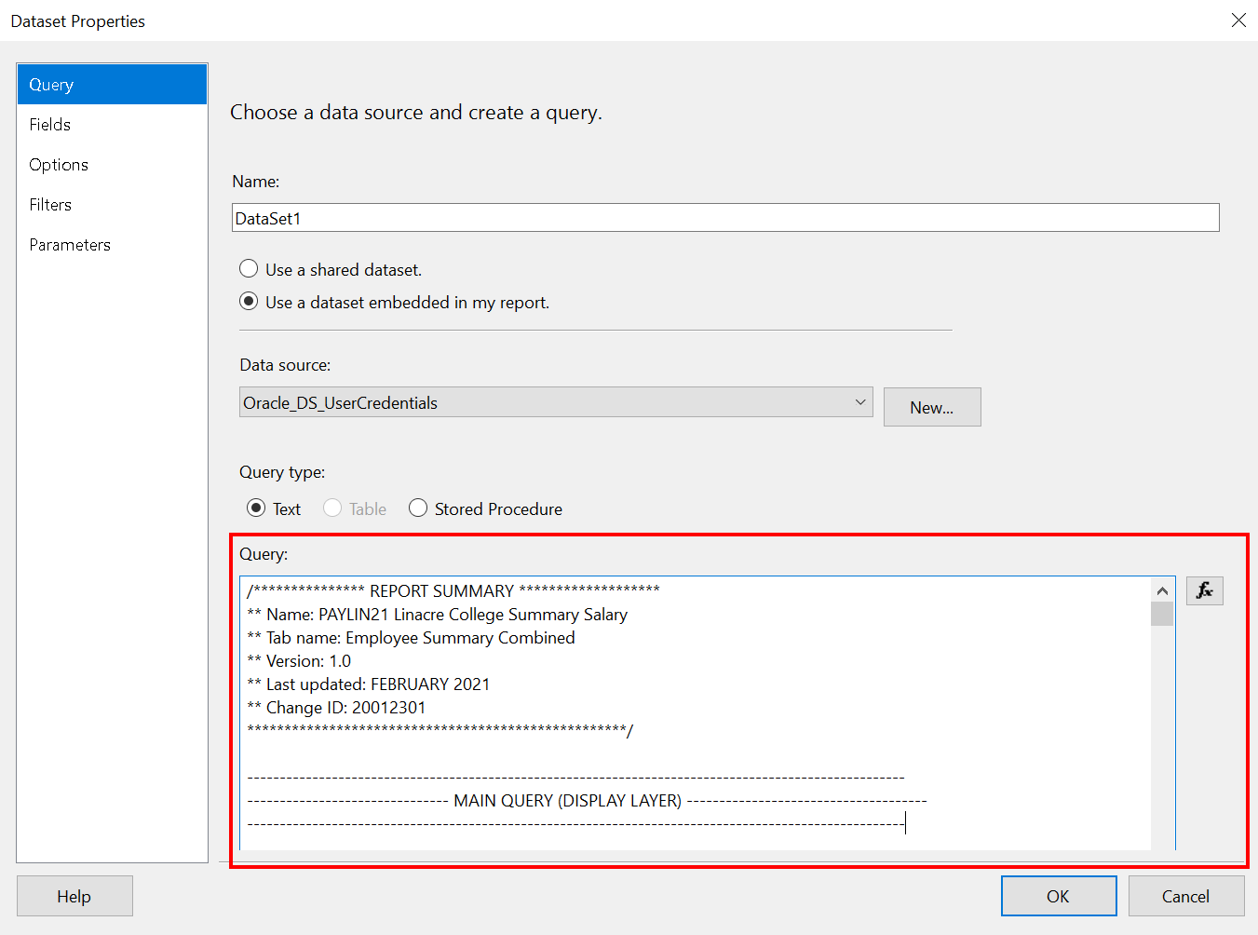

Click into the Query pane and edit the Report Summary header as necessary for each .RDL file in your amended report suite. You must update the following details:
- Version number: the newest version number of the report suite.
- Last updated: the month and year in which the newest version was published.
- Change ID: the OSM change request which contains all the details of what you are amending in the report suite and why.

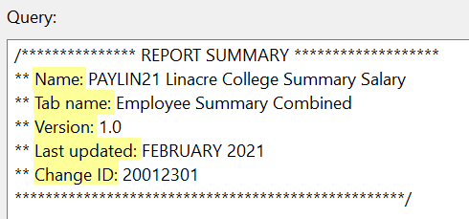
Refer to the Report Summary headers section for more detail on this step.

 | As noted above, it is essential that every .RDL file within a report suite has the same version number, because versioning is done at the report suite-level, not the .RDL file-level.

Once you have edited the Report Summary header for an .RDL file, click OK to exit the Dataset Properties window. On the main screen, enter Ctrl + Shift + S or click the “Save All” icon to save your changes to the .RDL files:

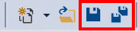

Deploy .RDLs to HR Reporting QA environment
Once you’ve updated the version numbers on the .RDLs of your amended report, and updated the Report Summary headers in each .RDL file, you can deploy the files to the HR Reporting QA environment. The .RDL file(s) you have just deployed will be located in the _Deployment folder.

Update the report folder properties
You now need to amend the existing report folder within the QA folder hierarchy before you can move your .RDL files out of the _Deployment folder.

From the Home page, go to the relevant navigation folder/subfolder within the HR Reporting QA folder hierarchy where the existing report folder is located.

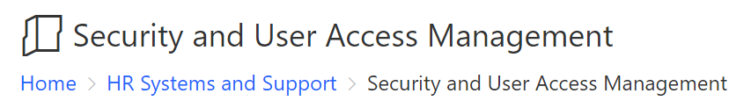

Click the ellipsis (…) next to the folder name and select “Manage”:

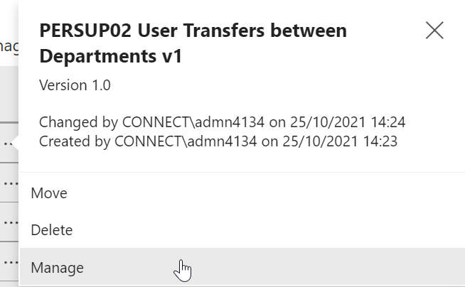

You will be taken to the folder’s Properties tab. Add the updated version number to the “Name” and “Description” fields, as shown below:

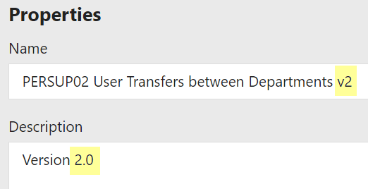

This enables anyone navigating to the navigation folder/subfolder to see which version of a report suite is available there. Click “Apply” to save your changes.

File .RDLs in HR Reporting QA folder hierarchy
Once you’ve updated the folder properties for your amended report, you can move your .RDL file(s) into it. Navigate to Home _Deployment to select your .RDL files and then follow the linked process to move the .RDLs into the amended report folder.

Check that your files are appearing correctly in the report folder, then share a link to the report folder with the end-user who requested the change(s) to the existing report, and ask them to perform UAT.

Archive .RDLs from the previous version
Once the end-user or HR Functional Analysis team confirms that the amended .RDLs have passed UAT, you will need to archive all the .RDLs from the previous version of the report in the _Back-Up Versions folder on the HR Reporting QA server.

LIVE solution & environment

STOP: All amended .RDL files must be tested and approved by either the end-user who requested the new report, or (in certain circumstances) the HR Functional Analysis team.. You must record the result of the User Acceptance Testing (UAT) on your OSM change request. Note that if the end-user has emailed you directly (rather than via the linked OSM incident), you must attach the email to the change request for future reference.

Your OSM change request must also have formal approval before you can add the .RDL files for your amended report to the HR Reporting LIVE solution in Visual Studio, or deploy them to the HR Reporting LIVE environment.

Do not proceed until you have explicit confirmation from the end-user or the HR Functional Analysis team that the amended .RDL files have passed UAT and your OSM change request has been scheduled for implementation.

Move the .RDL files
Once your OSM change request has been scheduled for implementation, you are ready to make your amended report available for users on the HR Reporting LIVE server.

Begin by moving your .RDL files from the HR Reporting_QA solution into the HR Reporting_LIVE solution.

Remove version numbers from .RDL filenames
It is not necessary to include version numbers in the filenames of .RDLs in the HR Reporting_LIVE solution, because the LIVE solution should only ever hold the most recent version of any report suite.

To remove the version number from a filename, right-click your .RDL file in the Reports list within the Solution Explorer. The right-click menu will open. Select “Rename”:



Remove the version number (e.g. “_v3”) from the end of the filename and hit Enter to save your changes. You will need to repeat this step for all the .RDL files in your amended report suite in the LIVE solution.

When you are done editing your .RDL filenames, enter Ctrl + Shift + S or click the “Save All” icon to save your changes to the .RDL files:



Deploy .RDLs to HR Reporting LIVE environment
You are now ready to deploy the .RDL files to the HR Reporting LIVE environment. The .RDL file(s) you have just deployed will be located in the _Deployment folder.

Delete .RDLs from previous version
All back-up copies of report suites are archived in the HR Reporting QA environment, so there is no need to retain previous versions in the LIVE environment. When you are ready to file your amended .RDLs in their report folder, you will need to delete the .RDLs from the previous version of your amended report.

Go to the active report folder and select all the .RDL files from the previous version. At the top of the screen, click “Delete”:
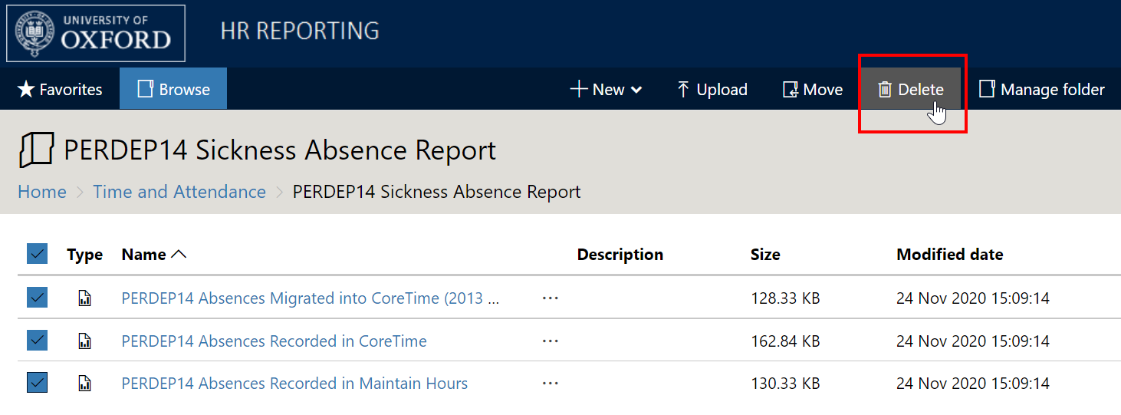

A warning message will appearing, asking you to confirm your decision to delete the .RDLs:

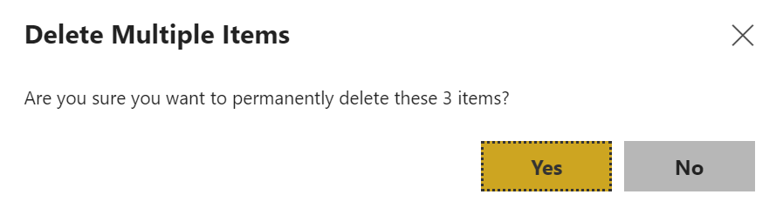

Click “Yes” to proceed. The files will be permanently deleted from the LIVE environment and the active report folder will be empty:

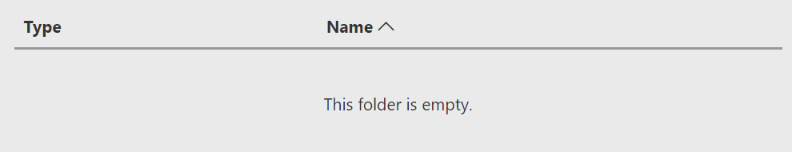

You can now move your amended .RDL files into the empty folder.

Move .RDLs into amended folder
Once you’ve deleted the .RDLs from the previous version of the report, you can move your amended .RDL file(s) into the report folder. Navigate to Home _Deployment to select your .RDL files and then follow the linked process to move the .RDLs into your report folder.

Check that your files are appearing correctly in the report folder before marking your OSM change request as “Implemented”.

Check the Live Reports Tracker
If, as part of your amendments to a report suite, you are changing any of the following aspects of the report, you will need to update the Live Reports Tracker spreadsheet:
- Prefix
- Report Name
- Folder Location
- Folder Security
Refer to the process below for further information on when and how to update the Live Reports Tracker.

Retired reports
It is periodically necessary to review the HR Reporting catalogue and to retire those reports which are no longer in use.

STOP: Removing a report from the HR Reporting catalogue is a business decision, and as such it must be discussed with and approved by the HR Business Change team. Business Change may wish to put the question to the Product Ownership Groups (POGs) who have traditionally used the report, to ensure that it is safe to retire it.

Do not proceed until you have formal agreement from the Business Change team that your report is ready to be retired.

Once you have agreement from the Business Change team that a report can be retired from the HR Reporting catalogue, follow the steps below.

Retiring a full report suite
Note: the steps below should be used when a full report suite (i.e. all the .RDL files within the suite) is being retired. If any .RDL files within the report suite are to remain active, please refer to the steps for retiring individual .RDL files.

QA environment

Archive .RDL file(s)
First, you will need to archive all .RDLs from the retired report suite in the _Back-Up Versions folder of the HR Reporting QA environment.

Delete active report folder
Once you’ve archived the .RDLs for your retired report suite, return to the (now empty) active report folder. At the top of the screen, click “Manage folder”:

You will be taken to the folder’s Properties tab. Click “Delete”:

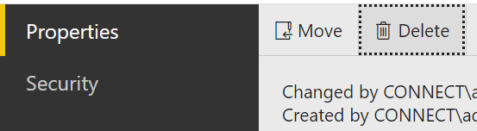

A warning message will appear, asking you to confirm your decision. Click “Delete” again to delete the folder from the folder hierarchy:

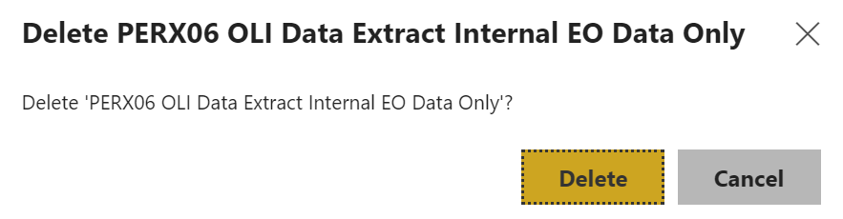

Update the report folder properties
Now that you’ve archived the .RDL files and deleted the active report folder, you need to make a note on the report suite’s archive folder, indicating that it contains a retired report. At the top of the screen, click “Manage folder”:

You will be taken to the folder’s Properties tab. Amend the “Description” field with a note indicating that the report suite is retired, and the date that the .RDLs were archived. Include the OSM Change ID for reference:

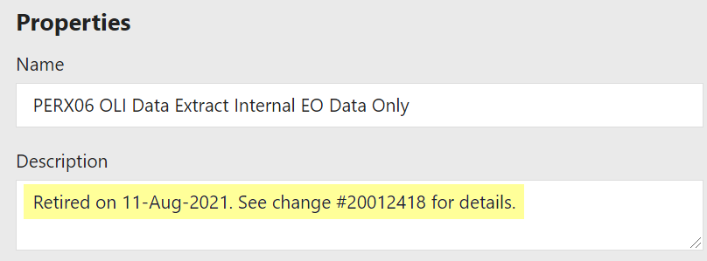

Click “Apply” to save your changes.

LIVE environment

Delete report suite from LIVE environment
Once you’ve archived the retired report suite in the HR Reporting QA environment, you need to delete it from the LIVE environment. Go to the live report folder and click “Manage folder” at the top of the screen:

You will be taken to the folder’s Properties tab. Click “Delete”:



A warning message will appear, asking you to confirm your decision. Click “Delete” again to delete the folder and all of its contents from the folder hierarchy:



Update the Live Reports Tracker
Follow the process below to update the Live Reports Tracker spreadsheet to reflect the fact that the retired report is no longer part of the HR Reporting catalogue.

Retiring individual .RDL files within a report suite
Note, the steps below should be used where individual report(s) are being retired from a full report suite but other reports within the suite are remaining. If the full set of reports are being retired please follow the steps above.

QA environment

Update the report properties
First, you need to make a note in the Description field for each individual .RDL file which is being retired from the active report suite. of the latest version of the individual .RDL files which are being retired.

Navigate to the report folder within the QA environment and select the .RDL which is being retired. Click on the ellipsis (…) next to the report name and select “Manage”:

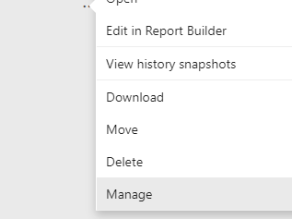

You will be taken to the .RDL file’s Properties tab. Amend the “Description” field with a note indicating that the .RDL file is retired, and the date that it was archived. Include the OSM Change ID for reference:

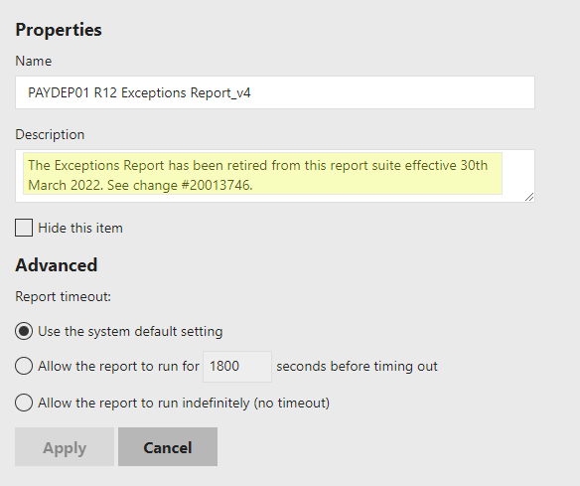

Click “Apply” to save your changes. Repeat these steps for as many .RDLs within the report suite as you need to retire.

LIVE environment

Delete .RDL file(s)
A back-up copy of the retired report will be archived in the HR Reporting QA environment, so there is no need to retain a version in the LIVE environment. You will therefore need to delete any .RDLs which are being retired from the LIVE environment.

Go to the active report folder and select the .RDL file(s) you wish to retire. At the top of the screen, click “Delete”:

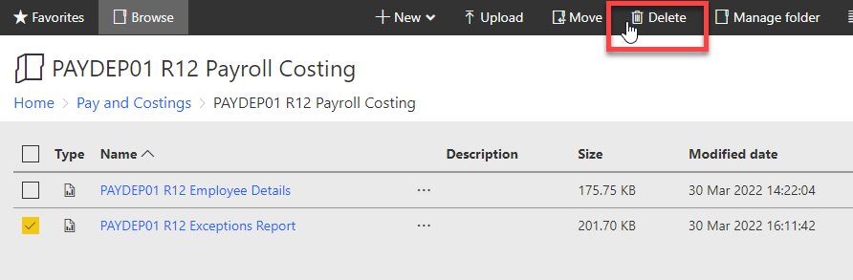
A warning message will appearing, asking you to confirm your decision to delete the .RDL(s):

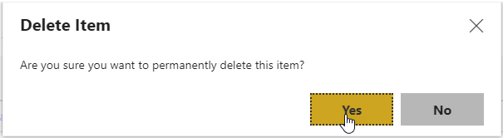

Click “Yes” to proceed. The file(s) will be permanently deleted from the LIVE environment and only the active .RDL(s) within the report suite will remain:

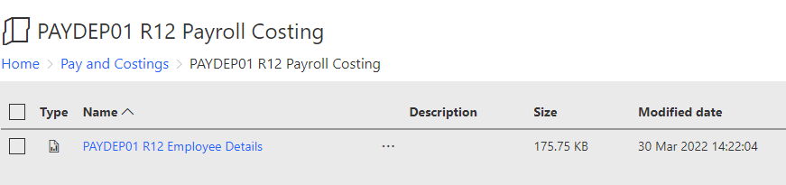

Updating the Live Reports Tracker
The Live Reports Tracker is a spreadsheet maintained by the HR Functional Analysis team. It is used to allocate prefixes to new or renamed reports (e.g. TIMDEP01), and to record the location of each report suite within the HR Reporting folder hierarchy.

 | These steps are essential for all new report suites, but are rarely required for amended reports unless certain conditions are met.

New reports
If you have created a new report, you will need to assign it an appropriate prefix and determine where it will be filed in the HR Reporting folder hierarchy.

Assign a prefix
Report names are all prefixed with an alphanumeric code in the form “XXXYYY##”. This code contains the following information:

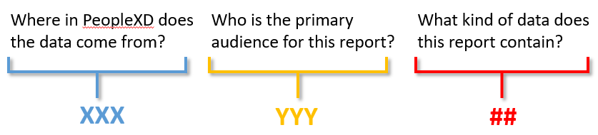

The “XXX” segment of the code indicates the report’s primary data source – for example, a personnel report will draw the majority of its data from the Personnel tables in the PeopleXD database, while a payroll report will draw the majority of its data from the Payroll tables in the PeopleXD database.

The “YYY” segment of the code indicates the report’s primary audience – for example, a personnel report will be mainly run by departments, while a pensions report will be mainly run by the Pensions Office.

The “##” segment of the code indicates the type of data the report contains:

- Current data: data from the database as it is today (e.g. “PERDEP01 Staff in Post”)
- Monthly reporting data: data from a given point in time, or from a certain date range (e.g. “PERDEP20 Monthly Personnel Changes”)
- Tracking data: data that is used to monitor various processes across the University (e.g. “PERDEP41 Immigration and Right to Work”)

See the prefix allocation key below – this is also present in the Live Reports Tracker.

Prefix key = Data Source + Audience + Report Type
Primary Data Source |  | Primary Audience |  | Report type
HRINFO | HESA | CTR | Central teams | 0-19 | Current data reports
PAY | Payroll | DEP | Departmental administrators | 20 - 39 | Point in time or date-range reports
PEN | Pensions | LIN | Linacre College | 40 - 89 | Tracking/monitoring reports
PER | Personnel | MGR | Payroll managers** | 90+ | Project reports
REC | Recruitment | PAY | Payroll team
SEC | Security | PEN | Pensions team
TRN | Training | SUP | HRIS Support Centre
 |  | X | Reports developed for specific users

To assign a prefix to your new report suite, open the Live Reports Tracker and go to the Prefix Allocation worksheet. This worksheet contains all the possible report prefixes available to choose from. Prefixes which are already in use are highlighted blue.

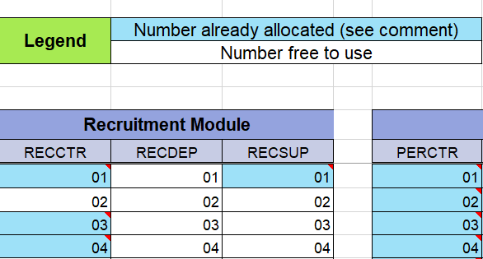
Blue cells all contain a comment which names the report to which the prefix is currently assigned. Hover over the cell to display the comment:

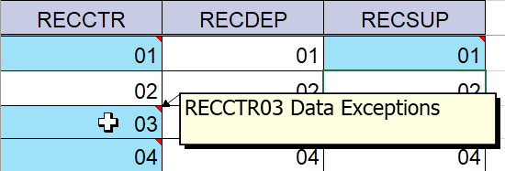

You will need to assign a prefix to your new report from the list of available prefixes.

 | A lot of reports use multiple data sources (e.g. Personnel and Training), and are used by multiple audiences (e.g. departments and Payroll). If you’re unsure about what prefix to assign your new report, speak to the HR Functional Analysis team.

Choose the prefix you wish to assign to your new report and click into the relevant cell within the prefix allocation matrix. Fill the cell with colour “Turquoise, Accent 2”, and right-click to insert a comment:

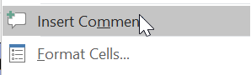

In the Comment box, enter the prefix and title of your new report suite:

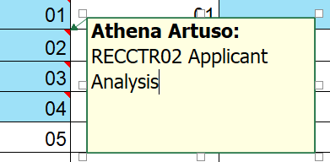

Click out of the Comment box to minimise it again.

Record report folder location and security
Now go to the Folder Structure worksheet. Here is where you will record where your new report is filed within the HR Reporting folder hierarchy, and which AD groups have permission to view your new report.

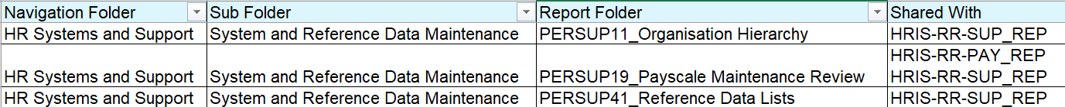

Filter the Navigation Folder and Sub Folder columns as appropriate for your new report. Right-click to insert a new row:

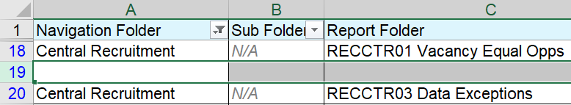

Copy the information for the Navigation Folder and Sub Folder into your new row, then enter the prefix and title of your new report into the Report Folder column. In the Shared With column, list the AD groups which have permission to access your new report:

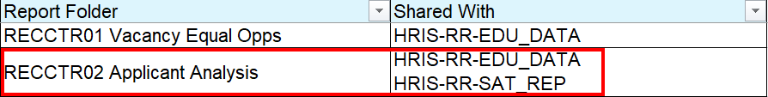

Update the Tracker version
Finally, go to the Version Control worksheet and update it with a new version number, along with notes explaining what you have changed about the document and why:

Save your changes to the Live Reports Tracker before closing the spreadsheet.

Amended reports
Generally speaking, you don’t need to update the Live Reports Tracker when you amend an existing report, unless you are amending one of the following properties of the report:

- The report’s prefix (e.g. PERDEP01)
- The report’s title (e.g. Staff in Post)
- The report’s location within the HR Reporting folder hierarchy (e.g. Home > Personnel > Current Reports)
- The AD groups which have permission to view the report in the HR Reporting_LIVE environment (e.g. HRIS-RR-PERDREP – Personnel).

If you are changing any of these things as part of the report amendments, you must update the report’s entry in the Live Reports Tracker.

Changing a prefix
If you are amending the report prefix (a very rare occurrence!), you must go to the Prefix Allocation worksheet and select the cell which contains the report’s old prefix. Change the cell colour from “Turquoise, Accent 2” to “None”. Right-click and select “Delete Comment” to remove the comment from the cell:

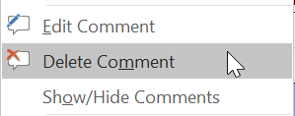

Now assign the new prefix to the report by following the steps outlined above. Then go to the Folder Structure worksheet and update the report’s entry there with the new prefix.

Changing a title
If you are amending the report’s title (also a rare occurrence!), you must go to the Prefix Allocation worksheet and select the report’s cell on the allocation matrix. Right-click and select “Edit Comment” to amend the report’s title in the Comment box:

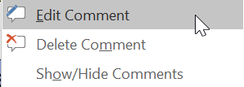

Click out of the Comment box to minimise it once you’re done.

Now go to the Folder Structure worksheet and update the report’s entry there with the new title.

Changing report folder location or security
If you are re-filing an amended report in a different area of the HR Reporting folder hierarchy, or if you are changing the list of AD groups which have access to the report, you must go to the Folder Structure worksheet and update the report’s entry there with the new Navigation Folder, Sub Folder, and/or Shared With details by following the steps outlined above.

Update the Tracker version
Finally, go to the Version Control worksheet and update it with a new version number, along with notes explaining what you have changed about the document and why:

Save your changes to the Live Reports Tracker before closing the spreadsheet.

Retired reports
When you retire a report suite, you must remove it from the Live Reports Tracker so that the report prefix is once again available for use.

Un-assign the prefix
Go to the Prefix Allocation worksheet and select the cell which contains the report’s old prefix.
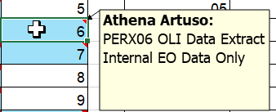

Change the cell fill colour from “Turquoise, Accent 2” to “None”. Right-click and select “Delete Comment” to remove the comment from the cell:



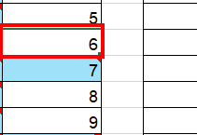

Remove report from Folder Structure
Now go to the Folder Structure tab. Filter the Navigation Folder and Sub Folder columns as appropriate for your retired report.

Right-click the report’s entry, and select “Delete”:

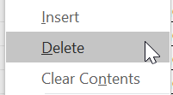

The record will be deleted from the Folder Structure tab.

Update the Tracker version
Finally, go to the Version Control worksheet and update it with a new version number, along with notes explaining what you have changed about the document and why:

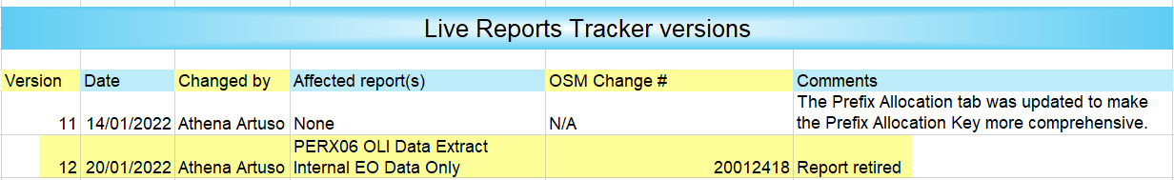

Save your changes to the Live Reports Tracker before closing the spreadsheet.

There may be circumstances where you wish to also deploy to the TEST server in order to test your new or edited report against a specific non-production environment. This is acceptable but it is not a mandatory part of the deployment process.
Ideally, there will always be an end-user who is able to perform UAT for a newly-created report. In some cases, however, the HR Functional Analysis team may need to perform UAT instead – for instance, if the new report was developed as part of a project, or if the end-user is unable/unavailable to perform UAT themselves. The HR Functional Analysis team occasionally develops reports for its own use, in which case they are the end-users and therefore the ones who should perform UAT.
As noted in the process for new reports, there will ideally be an end-user who can perform UAT here. However, it is sometimes necessary for the HR Functional Analysis team to perform the UAT – for instance, if the end-user is unable or unavailable to do it, or if the HR Functional Analysis team are themselves the “end-users” who requested the changes to the report suite.

